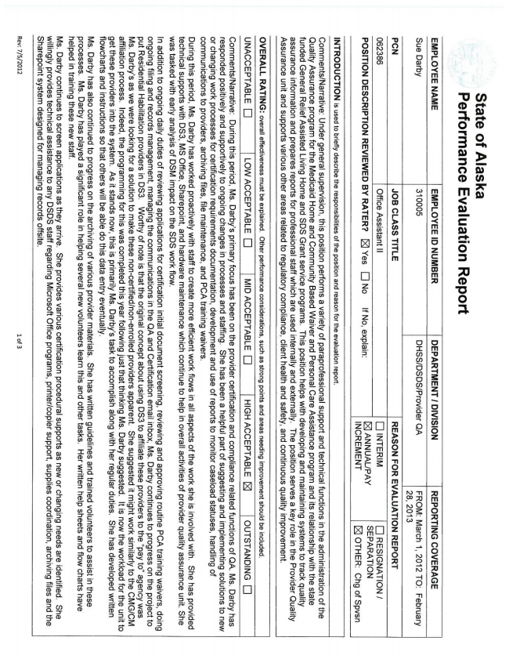

**State of Alaska Performance Evaluation Report**

**EMPLOYEE NAMEEMPLOYEE ID NUMBERDEPARTMENT I DIVISIONREPORTING COVERAGE Sue Darby310005DHSSDSDSProvider QAFROM: March 1, 2012 TO: February 28, 2013 PCNJOB CLASS TITLEREASON FOR EVALUATION REPORT 062386Office Assistant ||] INTERIM] RESIGNATION / POSITION DESCRIPTION REVIEWED BY RATER? ] Yes . No If No, explain] ANNUALPAYSEPARATION| NCREMENT] OTHER: Chg of Spvsn**

INTRODUCTION is used to briefly describe the responsibilities of the position and reason for the evaluation report.

CommentsNarrative: Under general supervision, this position performs a variety of paraprofessional support and technical functions in the administration of the Quality Assurance program for the Medicaid Home and Community Based Waiver and Personal Care Assistance program and its relationship with the state funded General Relief Assisted Living Home and SDS Grant service programs. This position helps with developing and maintaining systems to track quality assurance information and prepares reports for professional staff which are used internally and externally. The position serves a key role in the Provider Quality Assurance unit and supports various other areas related to regulatory compliance, client health and safety, and continuous quality improvement.

OVERALL RATING: overall effectiveness must be explained. Other performance considerations, such as strong points and areas needing improvement should be included.UNACCEPTABLE DELOW ACCEPTABLE DEMID ACCEPTABLE DEHIGH ACCEPTABLE .OUTSTANDING ] -

CommentsNarrative: During this period, Ms. Darbys primary focus has been on the provider certification and compliance related functions of QA. Ms. Darby has responded positively and supportively to ongoing changes in processes and staffing. She has been a helpful part of suggesting and implementing solutions to new or changing work processes for certification requirements documentation, development and use of reports to monitor caseload statuses, handling of communications to providers, archiving files, file maintenance, and PCA training waivers. During this period, Ms. Darby has worked proactively with staff to create more efficient workflows in all aspects of the work she is involved with. She has provided technical supports with DS3, MS Office, Sharepoint, and hardware maintenance which continue to help in overall activities of provider quality assurance unit. She was tasked with early analysis of DSM impact on the SDS workflow. In addition to ongoing daily duties of reviewing applications for certification initial document screening, reviewing and approving routine PCA training waivers, doing ongoing filing and records management, managing the communications in the QA and Certification email inbox, Ms. Darby continues to progress on the project to put Residential Habilitation providers in DS3, Worthy of note is that the original concept about using DS3 to affiliate these providers to the pay toagency was Ms. Darbys as we were looking for a solution to make these non-certifiednon-enrolled providers apparent. She suggested it might work similarly to the CMG/CM affiliation process. Indeed, the programming for this was completed this year following just that thinking Ms. Darby suggested. It is now the workload for the unit to get these providers into the system. As it stands now, this is primarily Ms. Darbys task to accomplish along with her regular duties. She has developed written flowCharts and instructions so that others will be able do this data entry eventually, Ms. Darby has also continued to progress on the archiving of various provider materials. She has written guidelines and trained volunteers to assist in these processes. Ms. Darby has played a significant role in helping several new volunteers learn this and other tasks. Her written help sheets and flow charts have helped in training these new staff. Ms. Darby continues to screen applications as they arrive. She provides various certification procedural supports as new or changing needs are identified. She willingly provides technical assistance to any DSDS staff regarding Microsoft Office programs, printercopier support, supplies coordination, archiving files and the Sharepoint system designed for managing records offsite.

Rev: /5/20121 of 3

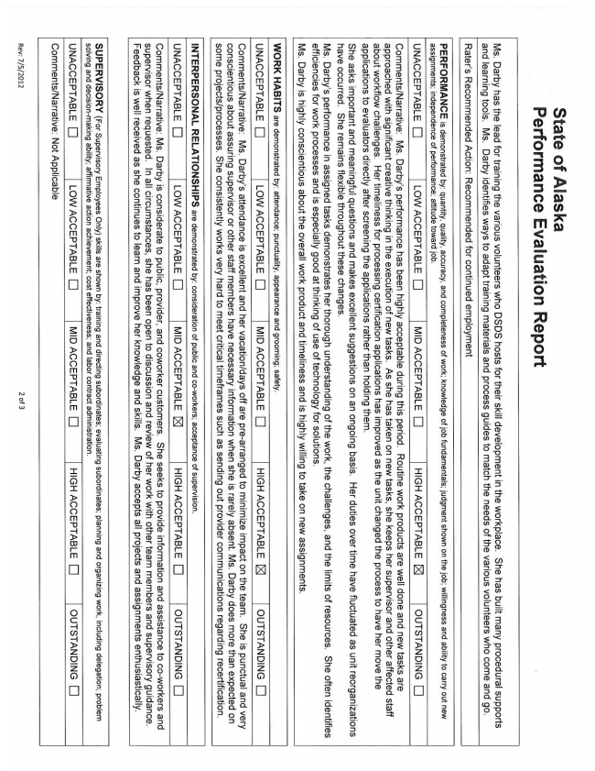

**State of Alaska Performance Evaluation Report**

Ms. Darby has the lead for training the various volunteers who DSDS hosts for their skill development in the workplace. She has built many procedural supports and learning tools. Ms. Darby identifies ways to adapt training materials and process guides to match the needs of the various volunteers who come and go,

Raters Recommended Action: Recommended for continued employment

PERFORMANCE is demonstrated by: quantity, quality, accuracy, and completeness of work; knowledge of job fundamentals, judgment shown on the jobwillingness and ability to carry out new assignments; independence of performance; attitude toward job.

UNACCEPTABLE DELOW ACCEPTABLE DEMID ACCEPTABLE DEHIGH ACCEPTABLE OUTSTANDING

CommentsNarrative: Ms. Darbys performance has been highly acceptable during this period. Routine work products are well done and new tasks are approached with significant creative thinking in the execution of new tasks. As she has taken on new tasks, she keeps her supervisor and other affected staff about workflow challenges. Her timeliness for processing certification applications has improved as the unit changed the process to have her move the applications to evaluators directly after screening the applications rather than holding them.

She asks important and meaningful questions and makes excellent suggestions on an ongoing basis. Her duties over time have fluctuated as unit reorganizations have occurred. She remains flexible throughout these changes.

Ms. Darbys performance in assigned tasks demonstrates her thorough understanding of the work, the challenges, and the limits of resources. She often identifies efficiencies for work processes and is especially good at thinking of use of technology for solutions.

Ms. Darby is highly conscientious about the overall work product and timeliness and is highly willing to take on new assignments.

WORK HABITS are demonstrated by: attendance; punctuality, appearance and grooming; safety.

UNACCEPTABLE DOLOW ACCEPTABLE DEMID ACCEPTABLEDHIGH ACCEPTABLE DXIOUTSTANDING DJ

CommentsNarrative: Ms. Darbys attendance is excellent and her vacationdays off are prearranged to minimize impact on the team. She is punctual and very conscientious about assuring supervisor or other staff members have necessary information when she is rarely absent. Ms. Darby does more than expected on some projectsprocesses. She consistently works very hard to meet critical timeframes such as sending out provider communications regarding recertification.

INTERPERSONAL RELATIONSHIPS are demonstrated by: consideration of public and coworkers; acceptance of supervision.

UNACCEPTABLE DOLOW ACCEPTABLE DEMID ACCEPTABLE HIGH ACCEPTABLE DJOUTSTANDING ]

CommentsNarrative: Ms. Darby is considerate to public, provider, and coworker customers. She seeks to provide information and assistance to coworkers and supervisor when requested. In all circumstances, she has been open to discussion and review of her work with other team members and supervisory guidance. Feedback is well received as she continues to learn and improve her knowledge and skills. Ms. Darby accepts all projects and assignments enthusiastically.

SUPERVISORY (For Supervisory Employees Only) skills are shown by: training and directing subordinates; evaluating subordinates; planning and organizing work, including delegation; problem solving and decisionmaking ability; affirmative action achievement; cost effectiveness; and labor contract administration.

UNACCEPTABLE DOLOW ACCEPTABLE DEMID ACCEPTABLE DEHIGH ACCEPTABLE DOOUTSTANDING ]

CommentsNarrative: Not Applicable

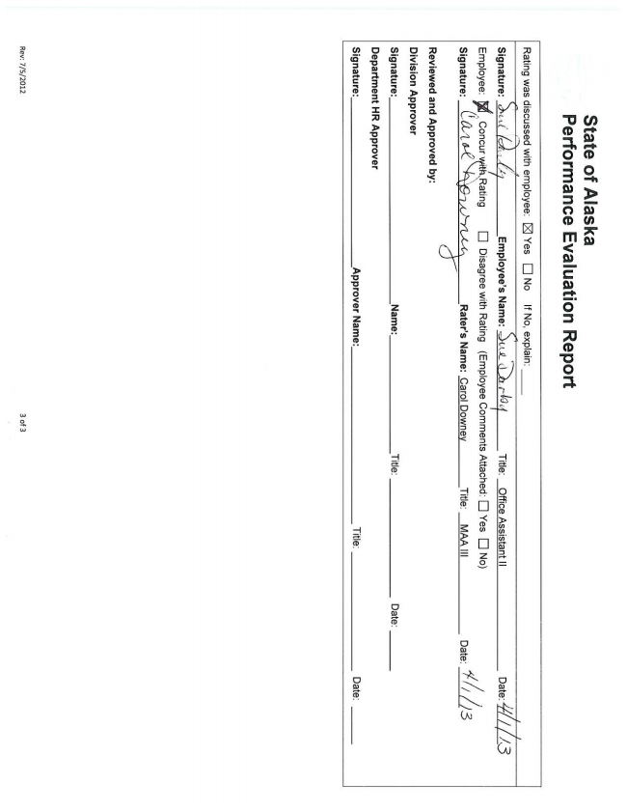

**State of Alaska Performance Evaluation Report**

Rating was discussed with employee: ] Yes [ ] No If No, explain:

-# Signature:,4Employees Name: .. coqTitle: Office Assistant ||Date////5 Employee. Žith Rating] Disagree with Rating (Employee Comments Attached: [ ] Yes DJ No)Signature:ruokaRaters Name: Carol DowneyTitle: MAA |||Date://

**Reviewed and Approved by:**

**Division Approver**

Date:

**Signature:Name:Title:Date: Department HR Approver Signature:Approver Name:Title:**